Pottsville Associate Reformed Presbyterian Church
The Lord’s Day Service
June 1st A. D. 2014
But you have come to Mount Zion and to the city of the living God, the heavenly Jerusalem, and to innumerable angels in festal gathering, and to the assembly of the firstborn who are enrolled in heaven, and to God, the judge of all, and to the spirits of the righteous made perfect, and to Jesus, the mediator of a new covenant, and to the sprinkled blood that speaks a better word than the blood of Abel. See that you do not refuse him who is speaking. For if they did not escape when they refused him who warned them on earth, much less will we escape if we reject him who warns from heaven. Therefore let us be grateful for receiving a kingdom that cannot be shaken, and thus let us offer to God acceptable worship, with reverence and awe, for our God is a consuming fire.
Hebrews 12:22-29

Christian Greeting

Sharing of Joys and Concerns

Prelude & Silent Preparation

God Calls Us To Worship Hebrews 12:22-29

We Respond to God’s Call
Pastor: May God be gracious to us and bless us and make his face to shine upon us that your way may be known on earth, your saving power among all nations.
People: Let the peoples praise you, O God; let all the peoples praise you!
Pastor: Let the nations be glad and sing for joy, for you judge the peoples with equity and guide the nations upon earth.
People: Let the peoples praise you, O God; let all the peoples praise you!
Pastor: The earth has yielded its increase; God, our God, shall bless us.
People: God shall bless us; let all the ends of the earth fear him!

Prayer of Adoration

◊ Hymn “Lord of the Sabbath, Hear Us Pray” Trinity 390

◊ Confession Of Sin 1 Peter 3:13-19
Our gracious God and merciful Father, we confess that we have sinned against you this day and every day, in thought, word, and deed. We were born in sin and our sin is ever before us. If you kept a record of our sins, who could stand? But with you there is mercy and forgiveness through Christ. Forgive our many sins as a church, as families, and as individuals. Forgive our public sins and those that are known only to you.
Forgive us for our failure to do what you have commanded and our failure to restrain what you have forbidden. Grant us true repentance, which moves our lips, our hearts, and our hands to godly sorrow and holy action. By your Spirit, change our hearts from stone to flesh and make us into a holy people, pleasing in your sight and useful in your hand.

◊ Assurance of Pardon Romans 6:1-4

◊ Confession of Faith Apostle’s Creed Bible Songs, iv

◊ “Gloria Patri” Trinity 735

Responsive Reading Psalm 141, Trinity 836

Hymn “Abide With Me” Trinity 402

Sermon “Pressing On”
Scripture Zechariah 14:1-21
Pastoral Prayer & Lord’s Prayer

◊ Hymn “And Can It Be That I Should Gain” Trinity 455

Worship Through Giving
Offertory Prayer
◊ Doxology Trinity 731

◊ Benediction Numbers 6:24-25

◊ Response “To God be the Glory” Trinity 55

◊ Those who are able, please stand

THIS WEEK AT POTTSVILLE ARP
Pottsville
Associate Reformed Presbyterian
Church

The Lord’s Day 9:45 am Bible Study
10:45 am Lord’s Day Worship

Wednesday 8:00 pm Men’s Bible Study

A FEW THINGS YOU SHOULD KNOW
- If you are our guest today, we are glad you are here. Please take a minute to fill out the Guest Information Card in the pew and drop it in the offering plate so we can get to know you better.
- We believe that Christian Worship is a renewal of covenant vows between Christians and the Father, Son, and Holy Spirit. Consequently, our worship contains lots of congregational participation. Your part is in bold, but don’t worry if you get a little lost. Just keep your bulletin handy throughout the service.
- We are a family of families worshipping together. We are teaching our children to worship as they worship with us. If they cry or squirm, it’s OK; God has ordained “praise” from our children and infants. If things get desperate, a cry room is available in the rear of the Sanctuary.
- Restrooms are located both in this building and in the Fellowship Hall.

CONTACT US
Our Elders
Mr. Leslie Oates 479-967-1685 Mr. Matt Wylie 479-754-7805

Our Pastor
Rev. Howard Wheeler 479-970-1384

On the web at www.pottsvillearp.org

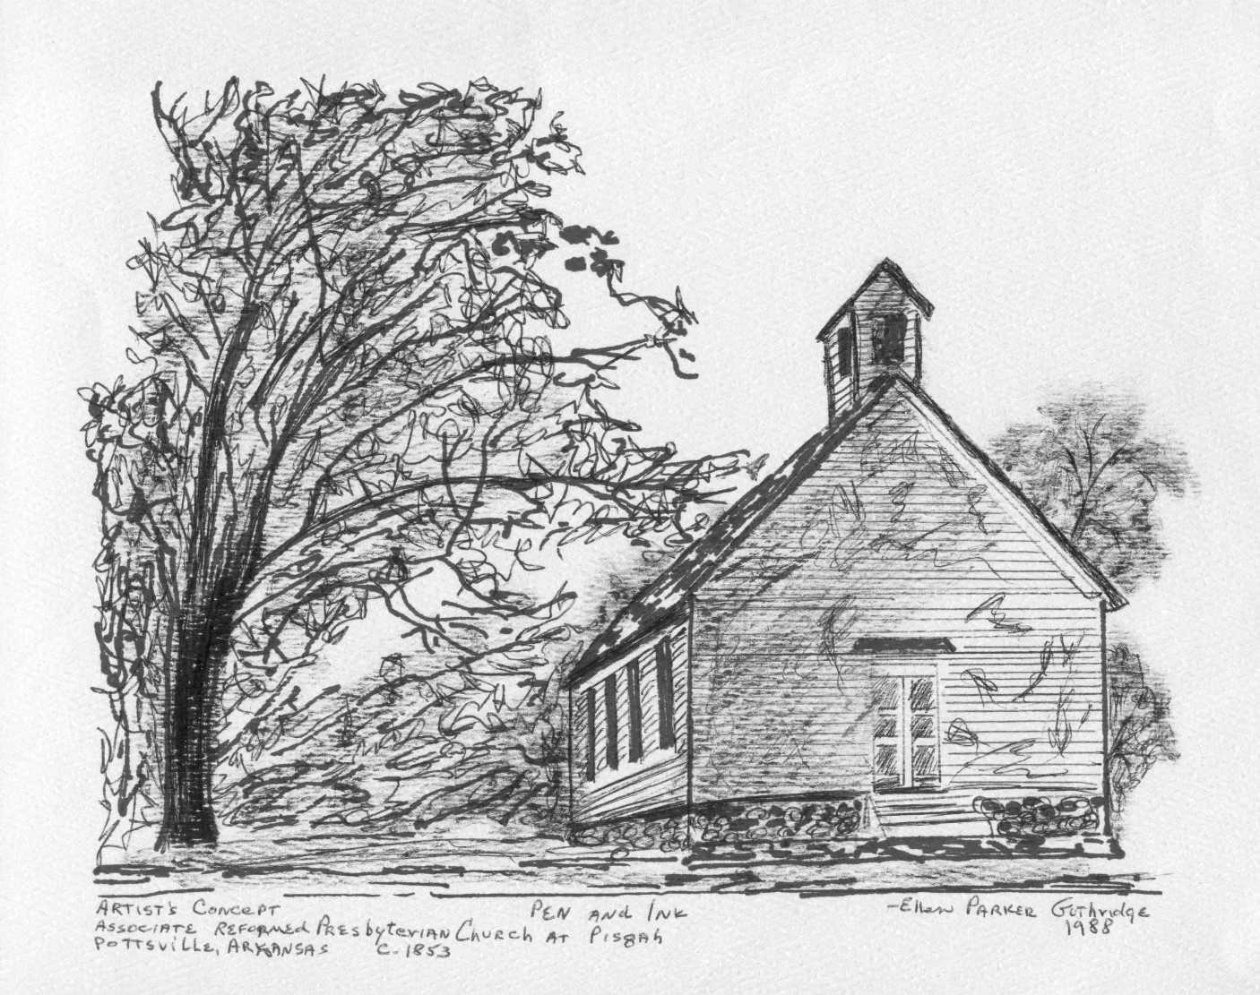

“Sharing this with our forefathers…that we too, are
desiring a better country; that is, the heavenly one.”
Hebrews 11:16

